Data Safety Monitoring Committee (DSMC)
OPEN Report
Date of Report: 5 Feb 2026

Name of trial: TEST trial - Randomised cancer treatment trial for example purposes
Meeting:
2nd meeting - Jan 2026
Trial registration number: Clinicaltrials.gov Identifier NCTXXXXXX
Based on: Protocol Version 1.0, Dated 1 August 2022
Investigators:
1. Dr Bob Smith
2. Dr Penny Hudson
Study biostatistician: Alannah Rudkin
Data and Safety Monitoring Committee Report produced by:
Alannah Rudkin
Murdoch Children's Research Institute
Melbourne

This report is based on data up to and including 14Jan2026.

Trial Summary

This trial is a multicentre, randomised, blinded, controlled trial with a parallel group design of treatment versus placebo.
The planned number of participants is 100 (50 per group).
With consent, eligible participants are randomly allocated using a web-based randomisation server, with stratification by cancer diagnosis type (brain, haematological, or gastrointestinal (GI)).
The primary aim of the study is complete response at 28 days.
Secondary aim of the study is lowered IgG level.
The current report includes all participants recruited and their follow-up data collected up to and including 14Jan2026, to allow for full data entry, data cleaning, data analysis, and report writing. The 48 th participant was randomised on 21Jul2025.

Protocol Amendments

Version 1.0, Dated 1 August 2022 is the most recent version of the protocol. No changes were made since the previous meeting. But if any changes were made this is where we'd put them.

1. Recruitment
The planned sample size is 100 participants, of which 50 will be assigned to each of the 2 study arms.
Figure 1 shows the accrual of the first 48 participants into the study up to the 14Jan2026, and Table 1 shows a breakdown of these participants by randomisation stratum.
Since the beginning of the study, there has been 1 issue related to the randomisation procedure. Details are listed below.
Electronic randomisation system was down for 24hours on 06Jan2025. Unable to randomise in this time. Back-up paper/phone randomisation system now available.
Table 1: Recruitment by randomisation stratum
 | Total
Number of Participants Randomised | 48
Cancer diagnosis type
GIT | 14 (29.2%)
Brain | 21 (43.8%)
Haematological | 13 (27.1%)

Figure 1: Recruitment Rate as of 14Jan2026
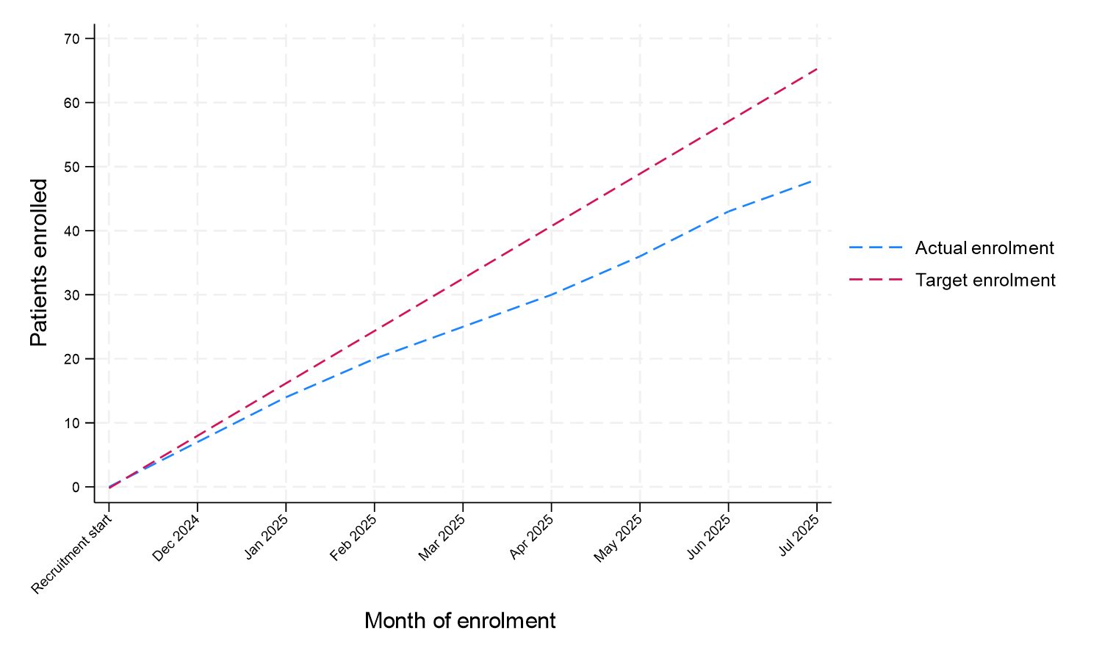
Table 2: Participant disposition
 | Total
 | N= 48
Baseline Data Available | 48 (100.0%)
Primary Outcome Data Available | 34 (70.8%)
Secondary Outcome Data Available | 48 (100.0%)
Withdrawn from the study | 3 (6.2%)
Lost to follow up | 3 (6.2%)

2. Participant Characteristics
Table 3 shows the baseline characteristics of the 48 participants recruited to date.
Table 3: Baseline characteristics
 | Total
 | N= 48
Patient age (years) | 55.9 (5.7)
Gender
Male | 28 (58.3%)
Female | 20 (41.7%)
Cancer diagnosis type
GIT | 14 (29.2%)
Brain | 21 (43.8%)
Haematological | 13 (27.1%)

3. Safety
3.1 Adverse events
Table 4 shows a summary of all the adverse events (AEs) before 14Jan2026. Listing 1 lists adverse event (AE) details.
Table 4: Adverse Events
 | Total
Number of Participants Randomised | 48
Participants who had at least one AE | 5 (10.4%)
Number of AEs: | 6
Number of AEs by category:
Blood and lymphatic system disorders | 2
Gastrointestinal disorders | 2
General disorders and administration site conditions | 1
Nervous system disorders | 1
Highest grade reported if multiple grades reported for the same participant adverse event.

Listing 1: Adverse events
Study ID | Adverse Event Number | Adverse Event - System Organ Class | Adverse Event term | Grade | Serious Adverse Event | Attribution to treatment | SUSAR
19 | 1 | Gastrointestinal disorders | Pancreatitis | 4 | 1 | 1 | 1
10 | 1 | Nervous system disorders | Peripheral motor neuropathy | 3 | 0 | . | .
33 | 1 | Blood and lymphatic system disorders | Febrile neutropenia | 3 | 1 | 1 | 0
41 | 1 | General disorders and administration site conditions | Fatigue | 2 | 0 | . | .
41 | 2 | Blood and lymphatic system disorders | Febrile neutropenia | 2 | 0 | . | .
9 | 1 | Gastrointestinal disorders | Diarrhea | 1 | 0 | . | .

Table 5: Serious Adverse Events
 | Total
Participants who experienced Serious Adverse Events | 2 (4.1%)
Total number of SAEs | 2
Relationship of the SAE to the trial
Possibly related | 2 (100.0%)
SAE category
Blood and lymphatic system disorders | 1 (50.0%)
Gastrointestinal disorders | 1 (50.0%)
Suspected Unexpected Serious Adverse Reaction | 1 (50.0%)
Highest grade reported if multiple grades reported for the same participant adverse event.

Table 6: Mortality
 | Total
 | N= 48
Participants died on trial | 31 (64.6%)

